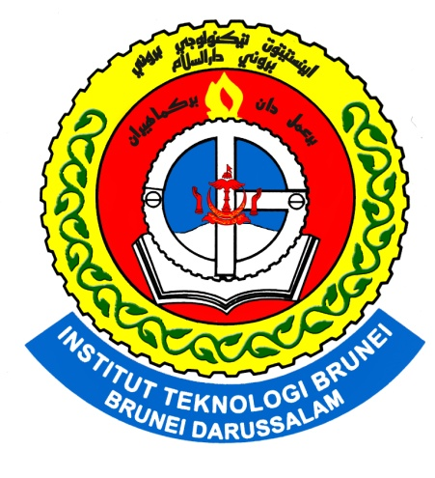

Institut Teknologi Brunei
Department of Electrical and Communication Engineering

Computer System Application
Operating System And Core Hardware
__________________
Course: HND in Electrical Power and Control Engineering
Name : Siti Nor Mahirah Binti Haji Baharun Zaman
I.D: 01-045091
Teacher: Dr. Haji Kamsani Bin Haji Ahmad

HARDWARE
- List down different kind of motherboard for the PC.
- ATX
- AX
- BTX
- NLX

- What is the different between AX and ATX motherboard? Sketch the layout of the two motherboards.
- AX Motherboard is the old type of motherboard while the ATX is the new type of motherboard. AX, It was originally from IBM. ATX is today motherboard that has been used. It was design by INTEL.
- The position of CPU for an ATX motherboard is in series to the expansion slot where as for an AX, it is in parallel to the expansion slot.
- The power connectors also differ between AT and ATX motherboards. AT motherboard use two 12-pin plugs to power the motherboard. An ATX motherboard uses one 20-pin plug for the power supply.

ATX Motherboard

AGP slot

CPU

PCI Slot

RAM Slot

IDE Slot
Power Supply
Flash BIOS
Floppy connector

AX Motherboard

RAM Slot

PCI Slot
ISA Slot

IDE Slot
Floppy connector

CPU Socket
Power Supply

- List the pins number of various kind of connector on the motherboard and at the back of the PC.

On the motherboard:
- IDE connector – 40 pins
- ATX power connector – 24 pins
- floppy connector- 34 pins

At the back of PC:
- USB – 4 pins
- P/2 – 6 pins
- serial port – 9 pins/15 pins
- firewire 1394 – 6 pins
- VGA – 15 pins

- What are the DC voltages we can find from the DC power supply?
- +12V,+5V

- List down the electrical problem we are facing when operating our PC?
- Electrical surge
- Blackout
- Flicker
- Out gates

- What are ESD, EMI and RFI?
- Electrostatic discharge
- Rapid discharge static electricity from one conductor to another of a different potential.
- Electromagnetic interference
- Electrical disturbance in the performance of electrical equipment.
- Radio frequency interference
- Disturbance frequency within a range

- List different kind of PC storage.
- ROM
- CD ROM
- SATA
- USB
- FLOPPY DISK

- List various kinds of RAM and their pin numbers.
- DRAM – 72 pins
- RDRAM – 184 pins
- SDRAM – 168 pins

OPERATING SYSTEM
- What is the function of OS?
- An operating system, or "OS," is software that communicates with the hardware and allows other programs to run. It is comprised of system software, or the fundamental files your computer needs to boot up and function.

- List down some of the OS that we can use in a small computer?
- Win 98
- Win XP
- Linux
- Win 2000
- Win 7

- What is the different between text based and graphic base OS?
- A text based OS is an OS that use a command line to operate the system. The example is MS DOS. A graphic based OS is not using text but it using graphic like Windows 3.1 was the first graphic based OS. New graphic based OS been use: Windows XP/vista/7

- List down some of the internal and external command of the text based and briefly explains the function of these commands.

INTERNAL COMMAND
- cd -To change directory
- cd.. -To go back to previous menu
- cd\ -To go to root directory

EXTERNAL COMMAD
- fdisk-To make partition
- format-To delete all date in the disk

- What is FDISK used for and then list down the menu that we can find under FDISK.
- Fdisk is used to create or delete partition in the hard drive.
- Create, set and display partition menu can be found

- Explain briefly what File System is.
- File system is a method of storing and organizing computer files and their data. Essentially, it organizes these files into a database for the storage, organization, manipulation, and retrieval by the computer's operating system.

- What is the different between physical and logical drive?
- A physical drive is drive that you can physically see in the computer system itself. It is also referred to as a hard drive or HDD (Hard Drive Device). For example, drives C:, D: and E: on a Windows PC can represent three physical drives

- List down the complete steps on how to install Windows 98 OS?
- Start up win98
- press key to the BIOS setup
- By pressing F2
- Detect Drive
- Select two boots from CD
- then set the setting to
- 1. Hard disk drive. 2. From floppy A;
- Click F10 to save
- On the screen enter Fdisk for partitioning
- select from the menu, create
- Then choose from list, to create a primary disk drive
- Then setup the no. of drive u want it to have,
- Then save, then partition is made
- Then set the partition to be set active
- Then restart the program by clicking ctrl+Alt+Delete
- Then go to D:\ then to f:\
- Enter format, to format your disk
- Then the win98 is setup

- What is the different between basic and dynamic disk?
- Basic disks are the storage types most often used with Windows. The term basic disk refers to a disk that contains partitions, such as primary partitions and logical drives, and these in turn are usually formatted with a file system to become a volume for file storage. Basic disks provide a simple storage solution that can accommodate a useful array of changing storage requirement scenarios. Basic disks also support clustered disks, Institute of Electrical and Electronics Engineers (IEEE) 1394 disks, and universal serial bus (USB) removable drives. For backward compatibility, basic disks usually use the same Master Boot Record (MBR) partition style as the disks used by the Microsoft MS-DOS operating system and all versions of Windows but can also support GUID Partition Table (GPT) partitions on systems that support it.
The following operations can be performed only on basic disks:
- Create and delete primary and extended partitions.
- Create and delete logical drives within an extended partition.
- Format a partition and mark it as active.

- Dynamic disks provide features that basic disks do not, such as the ability to create volumes that span multiple disks (spanned and striped volumes) and the ability to create fault-tolerant volumes (mirrored and RAID-5 volumes). Like basic disks, dynamic disks can use the MBR or GPT partition styles on systems that support both. All volumes on dynamic disks are known as dynamic volumes. Dynamic disks offer greater flexibility for volume management because they use a database to track information about dynamic volumes on the disk and about other dynamic disks in the computer. Because each dynamic disk in a computer stores a replica of the dynamic disk database, for example, a corrupted dynamic disk database can repair one dynamic disk by using the database on another dynamic disk.

The following operations can be performed only on dynamic disks:
- Create and delete simple, spanned, striped, mirrored, and RAID-5 volumes.
- Extend a simple or spanned volume.
- Remove a mirror from a mirrored volume or break the mirrored volume into two volumes.
- Repair mirrored or RAID-5 volumes.
- Reactivate a missing or offline disk.

